INFRAESTRUCTURES PER AL BIG DATA
(17244106, 17254118, 17924106)
HW2: People You May Know


Mauro Llorens Latorre
Frances Carmona

1. Initial Setup and Libraries
Google Drive is mounted in the Google Colab runtime environment, allowing access to files stored in the cloud from Python code.
PySpark modules are imported to work with RDDs and DataFrames.
A SparkSession named "HW2_Recomanador_Amics" is created to run distributed operations on a cluster or locally.

2. Directory Setup
The path to the input file stored in Google Drive is defined. This file contains the friendship data from a social network.

3. File Load as RDD
The file is loaded as an RDD of text lines.
take(5) is used to view a sample to inspect the structure.
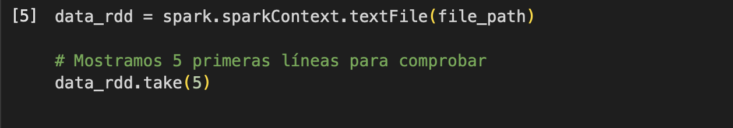
Result:
An RDD in the format [user\t friend,friend,friend…].
For example, user 3 has friends: 0, 12, 41, 55, 1532, 12636, 13185, 27552, 38737.

4. Preprocessing: Data Transformation

.split("\t"): separates the user ID and the list of friends.
.filter(...): removes empty or badly formatted lines.
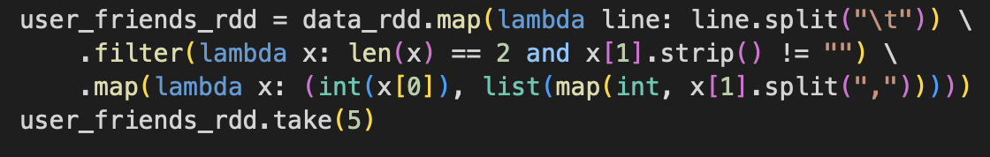
Result:
An RDD with pairs (user, list_of_friends), the basis for the recommendation logic.

5. Generation of Friend Pairs and Friends of Friends
All direct relationships (user, friend) are generated.
Result:
An RDD with potential recommendations is created:
If A and B are friends of C, then A and B might know each other.
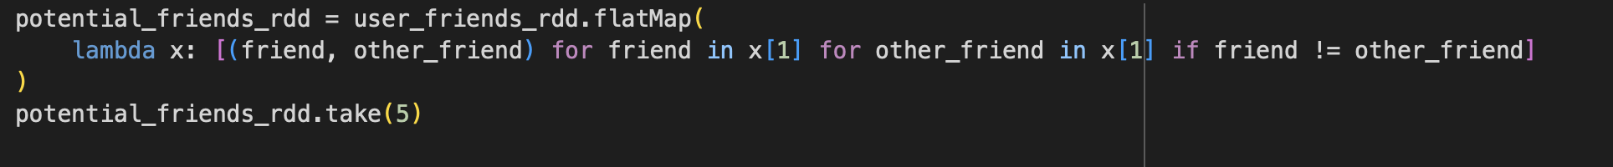
Result:
An RDD is created with pairs (user, user2), representing users who don't know each other but have mutual friends.

6. Filtering Existing Friendships

People who are already friends should not be recommended.
An RDD with structure ((friend, other_friend), recommendation_value) is created.
Existing friendships are marked with -1.
Result:
An RDD with pairs (user, user2), where the users are already friends.
Potential recommendations are assigned a value of 1.
Result:
An RDD is created with pairs, where the users are not friends and are recommended to each other.
Values for each pair (u, v) are summed.
Result:
If the sum is positive, it means they are not direct friends but have mutual friends → valid recommendation.
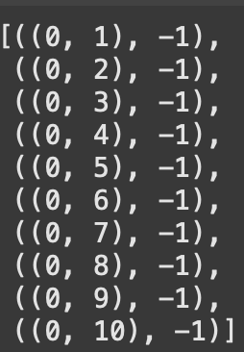
We now have an RDD with user pairs and their recommendation scores.
We filter this RDD to keep only those with a value greater than 0.
Result:
An RDD is created with pairs and recommendation values greater than 0:
((user, user2), value)
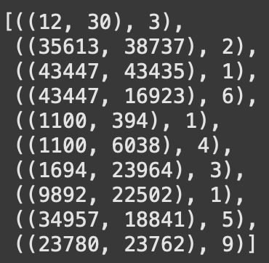

7. Grouping by User
Transformed into: (user, (recommended_user, mutual_friends))
All recommendations are grouped by user.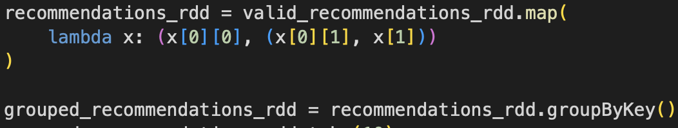
The recommendations for the first 10 users are shown.
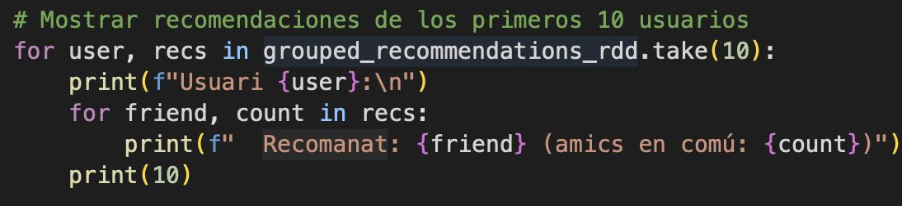
Result:
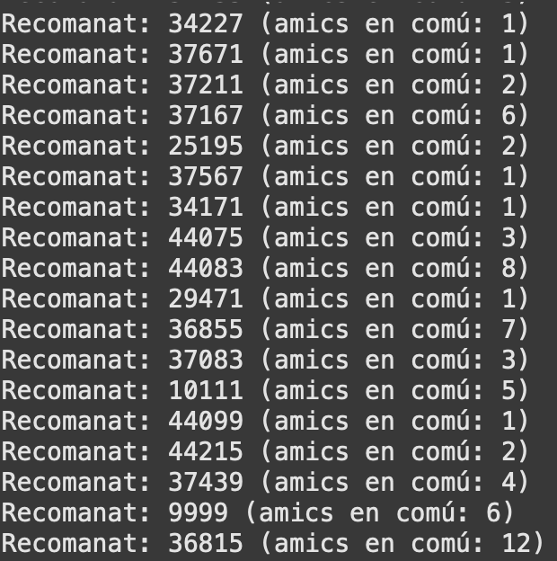

8. Selection of Top Recommendations
The 10 strongest recommendations per user are selected.
Sorting criteria:
– Highest number of mutual friends (-x[1])
– In case of a tie, lowest user ID (x[0])
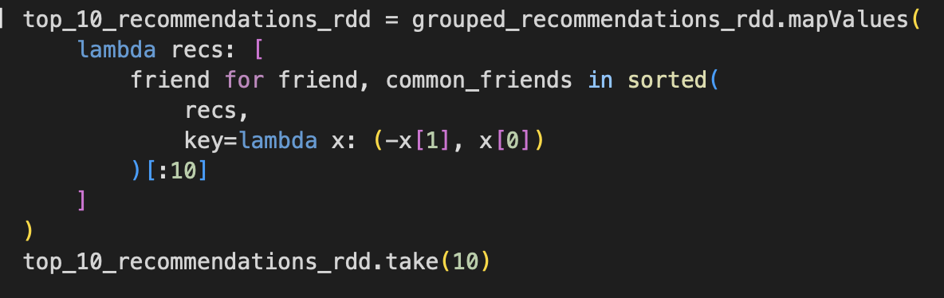
Result:
An RDD is generated with recommendation values greater than 0:
((user, user2), value)
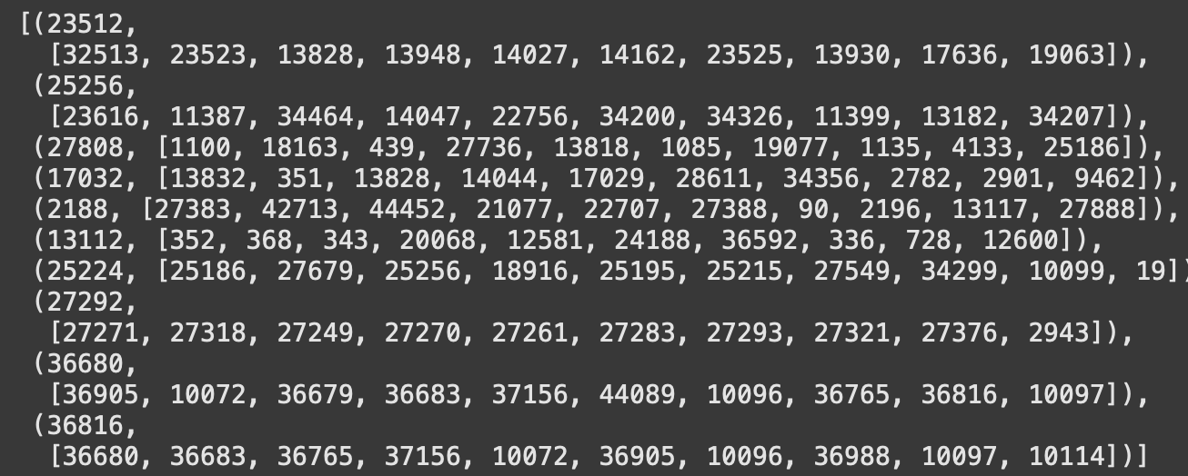
Text output is prepared in the format:
[user\t friend,friend,friend…] (same format as the input)
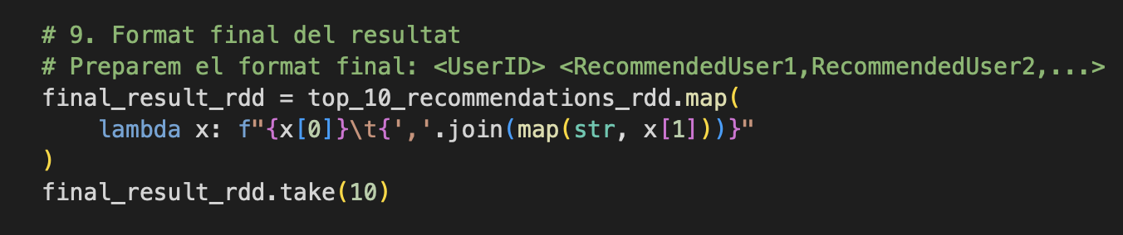
Result:
An RDD in the format [user\t friend,friend,friend…] is created.
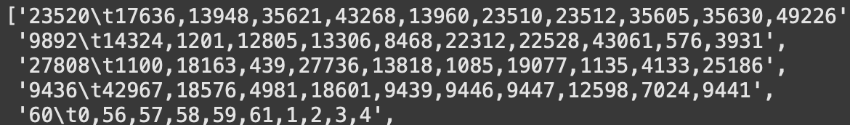

9. Specific Recommendations
The 10 strongest recommendations per user are selected.
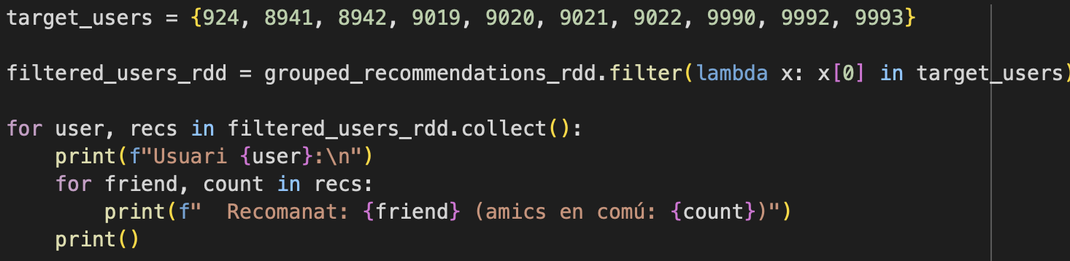
Result:
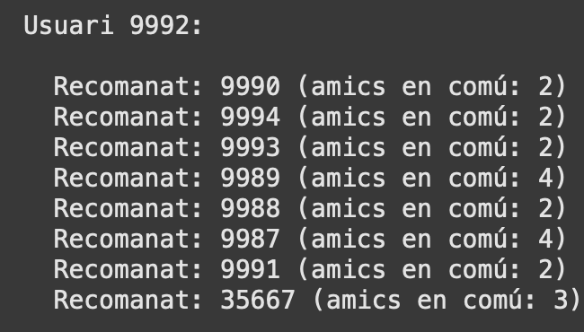

10. Saving Results
The output folder is deleted if it already exists.
The results are saved as .txt files in the specified directory.
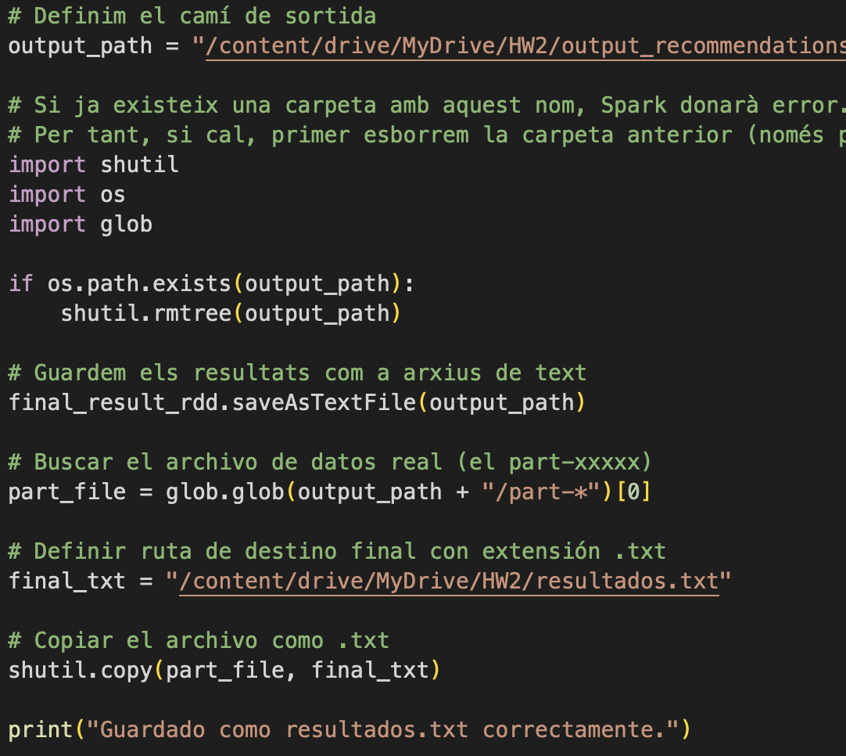
Result:
TXT file containing user recommendation results
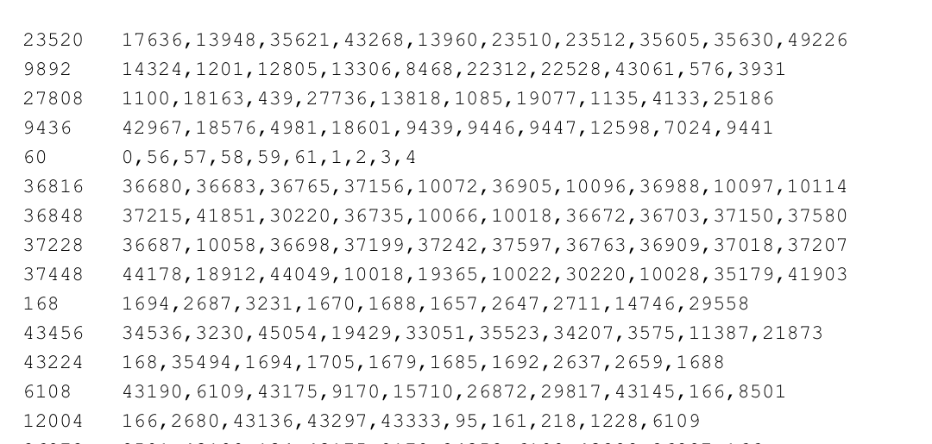

11. Conclusion
This project helped us understand how friendship recommendations work in social networks.
From a list of friends, the system suggests new connections based on mutual friends.
We learned how to process large amounts of data in an organized way and how to obtain useful results automatically.

